class Student {
int studentId;
String name;
int age;

Student() {
}

void display() {
System.out.println("Student ID: " + this.studentId);
System.out.println("Name: " + this.name);
System.out.println("Age: " + this.age);
System.out.println();
}

public static void main(String[] var0) {
Student var1 = new Student();
Student var2 = new Student();
Student var3 = new Student();
var1.studentId = 101;
var1.name = "Meghanadh";
var1.age = 19;
var2.studentId = 102;
var2.name = "Surya";
var2.age = 20;
var3.studentId = 103;
var3.name = "Rahul";
var3.age = 18;
var1.display();
var2.display();
var3.display();
}
}
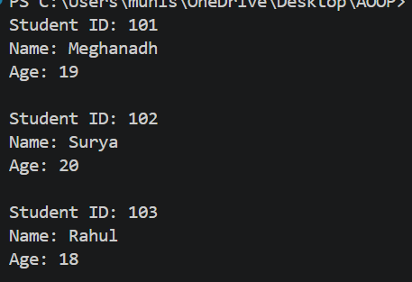

class Employee {
int empId;
String name;
double salary;

Employee(int id, String n, double s) {
empId = id;
name = n;
salary = s;
}

void display() {
System.out.println("Employee ID: " + empId);
System.out.println("Name: " + name);
System.out.println("Salary: " + salary);
System.out.println();
}

public static void main(String[] args) {

Employee e1 = new Employee(101, "Meghanadh", 25000);
Employee e2 = new Employee(102, "Surya", 30000);
Employee e3 = new Employee(103, "Rahul", 35000);

e1.display();
e2.display();
e3.display();
}
}
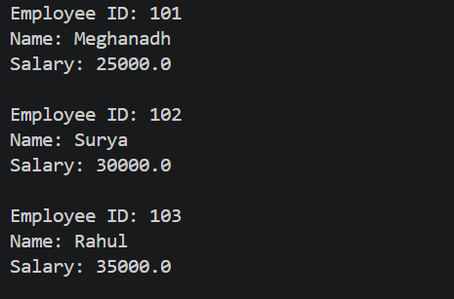

class BankAccount {
int accountNumber;
double balance;

BankAccount(int accNo, double bal) {
accountNumber = accNo;
balance = bal;
}

void deposit(double amount) {
balance = balance + amount;
System.out.println("Deposited: " + amount);
}

void withdraw(double amount) {
if (amount <= balance) {
balance = balance - amount;
System.out.println("Withdrawn: " + amount);
} else {
System.out.println("Insufficient balance");
}
}

void display() {
System.out.println("Account Number: " + accountNumber);
System.out.println("Balance: " + balance);
}

public static void main(String[] args) {
BankAccount b1 = new BankAccount(12345, 5000);

b1.display();

b1.deposit(2000);
b1.withdraw(1500);

System.out.println("After Transactions:");
b1.display();
}
}
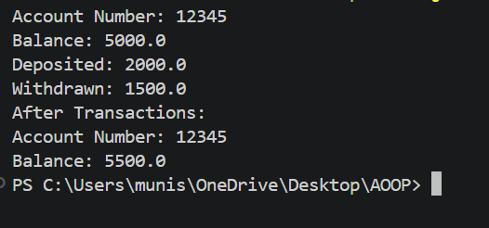

class Rectangle {
int length;
int width;

Rectangle(int var1, int var2) {
this.length = var1;
this.width = var2;
}

void calculate() {
int var1 = this.length * this.width;
int var2 = 2 * (this.length + this.width);
System.out.println("Length: " + this.length);
System.out.println("Width: " + this.width);
System.out.println("Area: " + var1);
System.out.println("Perimeter: " + var2);
}

public static void main(String[] var0) {
Rectangle var1 = new Rectangle(10, 5);
var1.calculate();
}
}
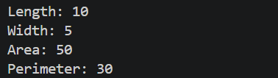

class Book {
int ISBN;
String title;
double price;

Book(int i, String t, double p) {
ISBN = i;
title = t;
price = p;
}

void display() {
System.out.println("ISBN: " + ISBN);
System.out.println("Title: " + title);
System.out.println("Price: " + price);
}

public static void main(String[] args) {

Book b1 = new Book(101, "Java Programming", 450);
Book b2 = new Book(102, "Python Basics", 500);

b1.display();

System.out.println();

b2.display();
}
}


